**Procedures**

1. DELIMITER &&
2. **CREATE** **PROCEDURE** procedure_name [[IN | **OUT** | INOUT] parameter_name datatype [, parameter datatype]) ]
3. **BEGIN**
4. Declaration_section
5. Executable_section
6. **END** &&
7. DELIMITER ;
8. CALL procedure_name ( parameter(s))
   * Use database name;
   * Table student_info

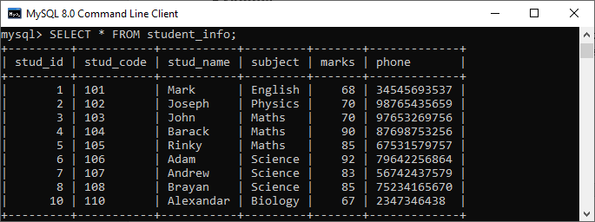

1. DELIMITER &&
2. **CREATE** **PROCEDURE** get_merit_student ()
3. **BEGIN**
4. **SELECT** * **FROM** student_info **WHERE** marks > 70;
5. **SELECT** COUNT(stud_code) **AS** Total_Student **FROM** student_info;
6. **END** &&
7. DELIMITER ;
8. mysql> CALL get_merit_student();

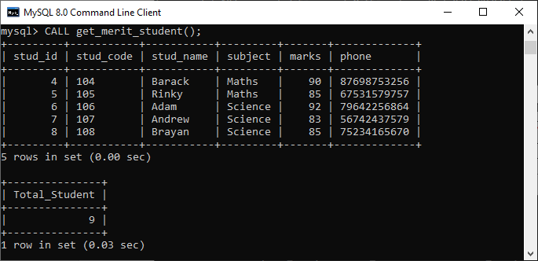

1. DELIMITER &&
2. **CREATE** **PROCEDURE** get_student (IN var1 **INT**)
3. **BEGIN**
4. **SELECT** * **FROM** student_info LIMIT var1;
5. **SELECT** COUNT(stud_code) **AS** Total_Student **FROM** student_info;
6. **END** &&
7. DELIMITER ;
8. mysql> CALL get_student(4);

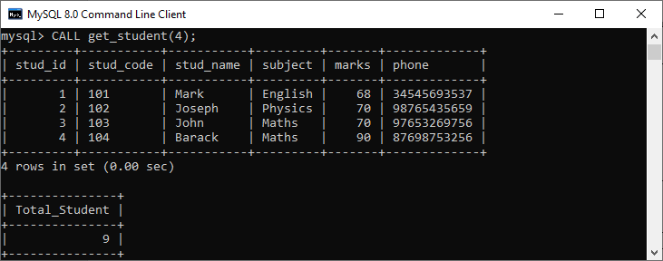

1. mysql> **DROP** **PROCEDURE** display_marks;

Creating a function

1. **CREATE** **FUNCTION** function_name [ (parameter datatype [, parameter datatype]) ]
2. **RETURNS** return_datatype
3. **BEGIN**
4. Declaration_section
5. Executable_section
6. **END**;

**Function_name:** name of the function

**Parameter:** number of parameter. It can be one or more than one.

**return_datatype:** return value datatype of the function

**declaration_section:** all variables are declared.

**executable_section:** code for the function is written here.

**Database:** employee

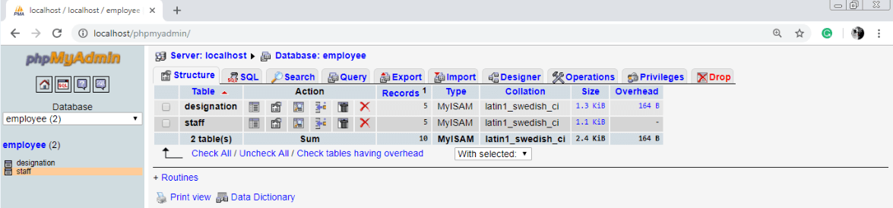

Table 1 : designation

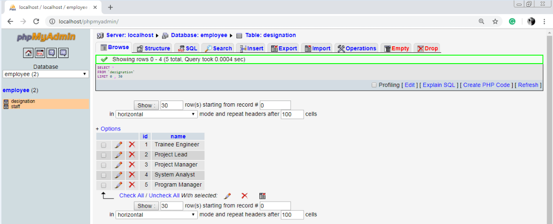

Table 2 : staff

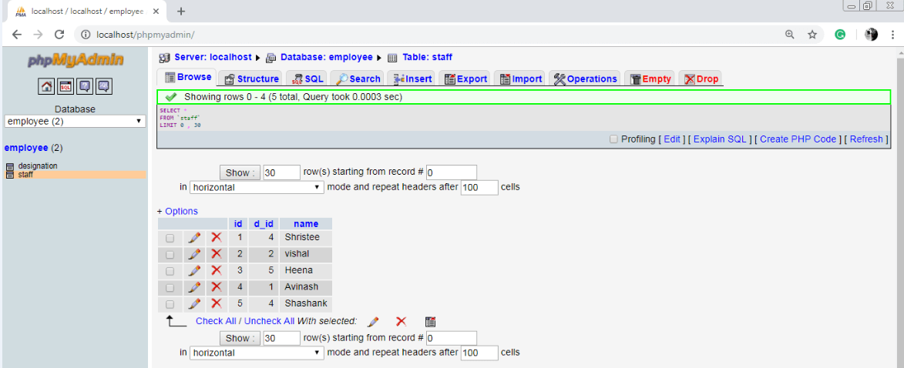

1. DELIMITER $$
2. **CREATE** **FUNCTION** get_designation_name(d_id **INT**) **RETURNS** **VARCHAR**( 20 )
3. **BEGIN**
4. **DECLARE** de_name **VARCHAR**( 20 ) **DEFAULT** "";
5. **SELECT** **name** **INTO** de_name **FROM** designation **WHERE** id = d_id;
6. **RETURN** de_name;
7. **END** $$

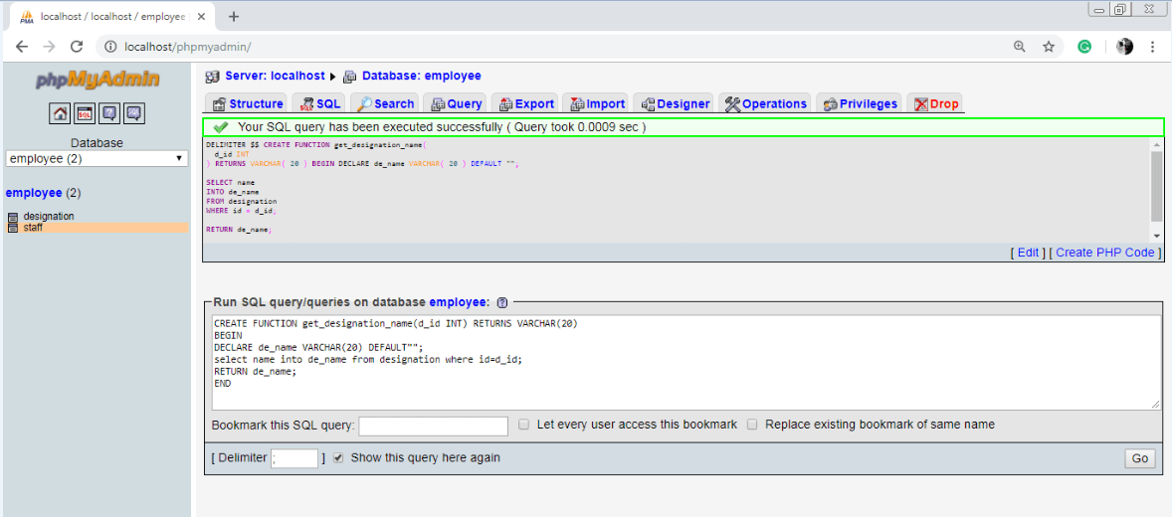

**Query :**

SELECT id, get_designation1(`d_id`) as DESIGNATION, name FROM 'staff'

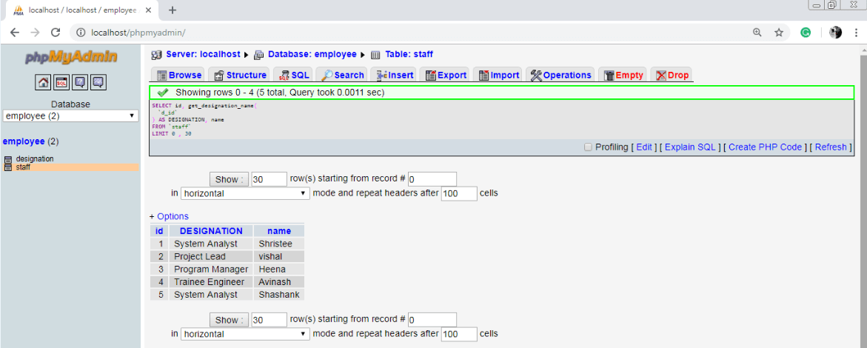

Drop a function

In MySQL Function can also be dropped. When A function id dropped, it is removed from the database.

Syntax:

1. **Drop** **function** [ IF EXISTS ] function_name;

**Triggers**

Introduction to MySQL triggers

BEFORE INSERT – activated before data is inserted into the table.

AFTER INSERT – activated after data is inserted into the table.

BEFORE UPDATE – activated before data in the table is updated.

AFTER UPDATE – activated after data in the table is updated.

BEFORE DELETE – activated before data is removed from the table.

**Trigger Activation Time:** BEFORE | AFTER

**Trigger Event:** INSERT | UPDATE | DELETE

1. **CREATE** **TRIGGER** trigger_name
2. (**AFTER** | BEFORE) (**INSERT** | **UPDATE** | **DELETE**)
3. **ON** table_name **FOR** EACH ROW
4. **BEGIN**
5. --variable declarations
6. --trigger code
7. **END**;
8. **CREATE** **TABLE** employee(
9. **name** **varchar**(45) NOT NULL,
10. occupation **varchar**(35) NOT NULL,
11. working_date **date**,
12. working_hours **varchar**(10)
13. );
14. **INSERT** **INTO** employee **VALUES**
15. ('Robin', 'Scientist', '2020-10-04', 12),
16. ('Warner', 'Engineer', '2020-10-04', 10),
17. ('Peter', 'Actor', '2020-10-04', 13),
18. ('Marco', 'Doctor', '2020-10-04', 14),
19. ('Brayden', 'Teacher', '2020-10-04', 12),
20. ('Antonio', 'Business', '2020-10-04', 11);

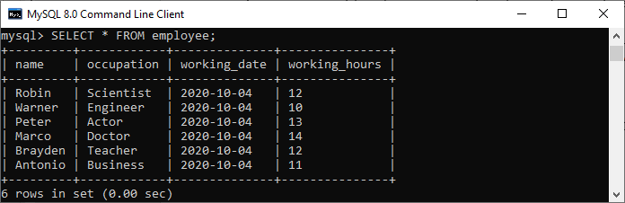

1. mysql> DELIMITER //
2. mysql> **Create** **Trigger** before_insert_empworkinghours
3. BEFORE **INSERT** **ON** employee **FOR** EACH ROW
4. **BEGIN**
5. IF NEW.working_hours < 0 **THEN** **SET** NEW.working_hours = 0;
6. **END** IF;
7. **END** //

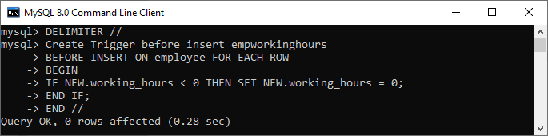

1. mysql> **INSERT** **INTO** employee **VALUES**
2. ('Markus', 'Former', '2020-10-08', 14);
4. mysql> **INSERT** **INTO** employee **VALUES**
5. ('Alexander', 'Actor', '2020-10-012', -13);

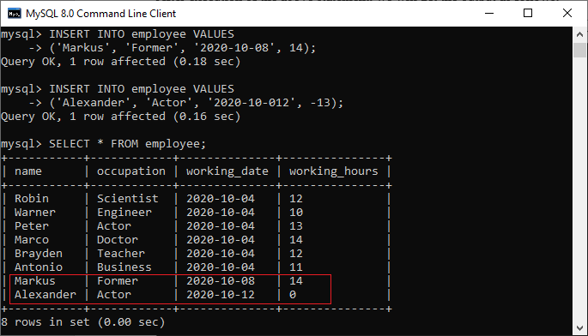

1. mysql>SHOW TRIGGERS;